Lab2:

**Creating Lambda Function to Be Triggered by SQS**

**Step 1 : Create Lambda Function**

* Go to ‘**Lambda**’ service on AWS console.
* Click ‘**Create function**’.
* Select ‘**Use a blueprint**’.
* Search ‘**SQS**’ in the the blueprints search bar.
* Select ‘**Process messages in an SQS queue**’.

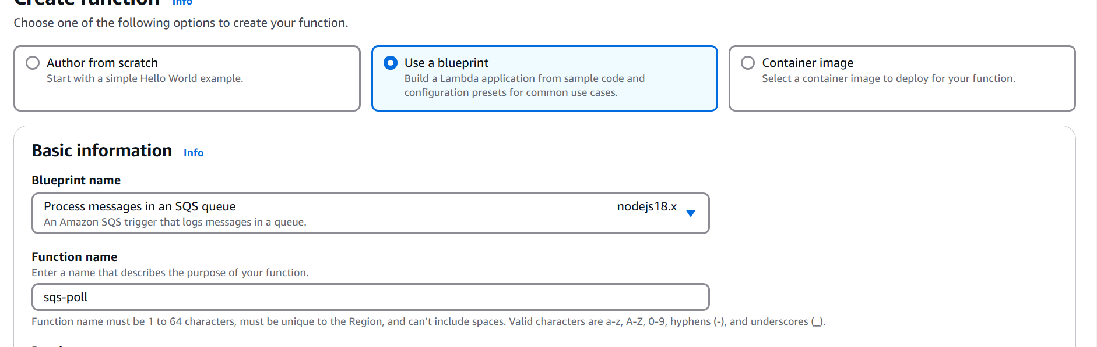

**Basic Information :**  
  
 **- Function name :** sqs-poll  
 **- Execution role :** Create a new role from AWS policy templates (Keep default)  
 **- Role name :** sqs-poll-role  
 **- Policy templates :** Keep the default "Amazon SQS poller permissions"

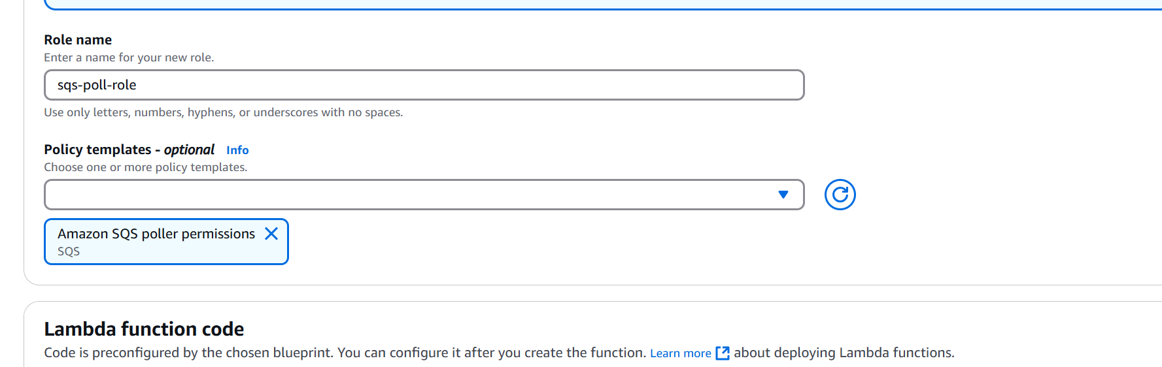  
  
**SQS trigger :**  
  
 **- SQS queue :** My-First-Queue  
  
**Note:** Keep the rest as default

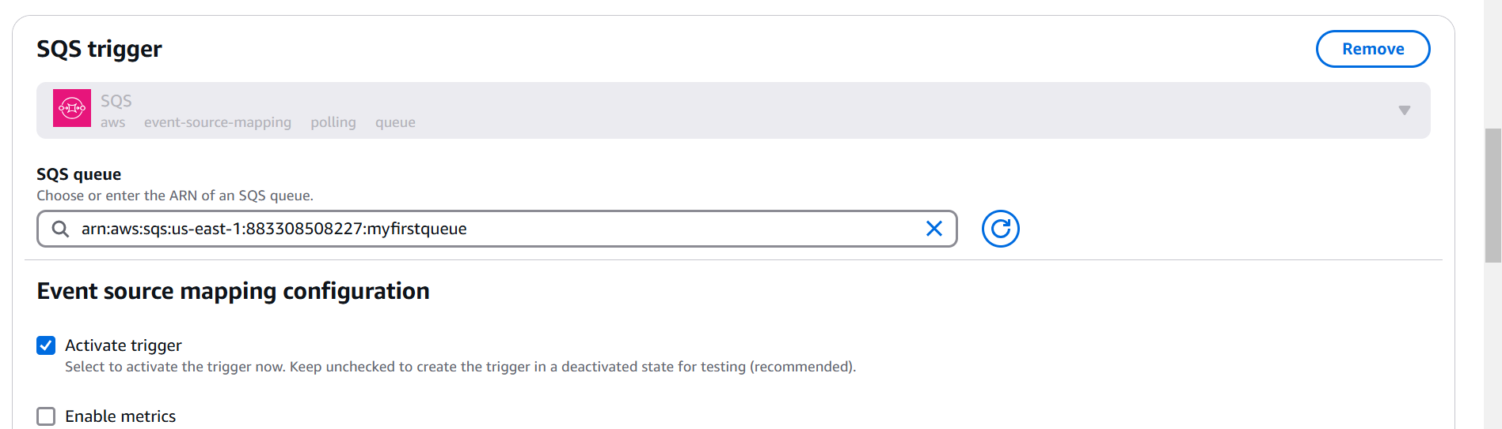

Click on SQS trigger

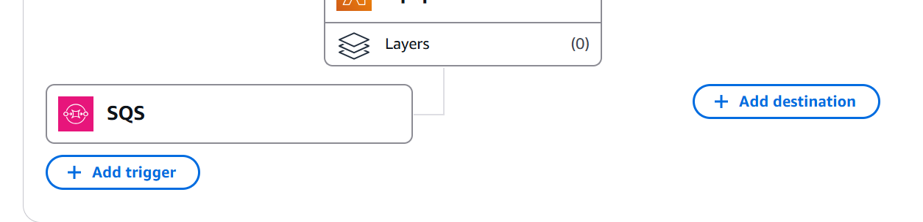

Check for enabled or not

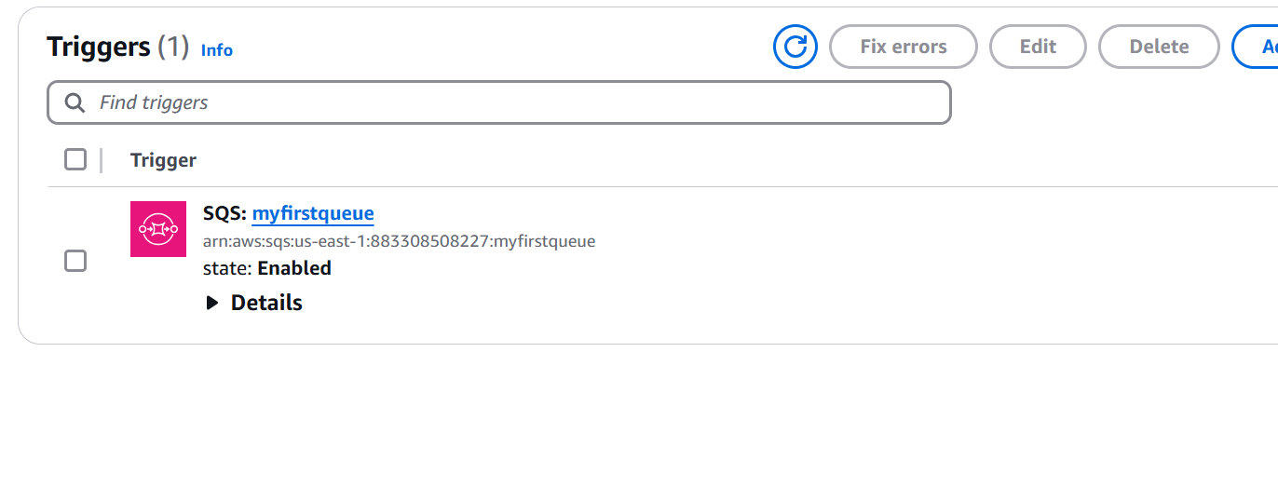

**Send Message to Invoke Lambda**

* Go back to ‘**SQS**’ service on AWS console.
* Send a new message like “**This message is sent from sqs to trigger lambda.**” to the ‘**My-First-Queue**’.
* Show there is no message since it has been polled by lambda. (Click ‘**Poll for messages**’ under ‘**Receive messages**’.)

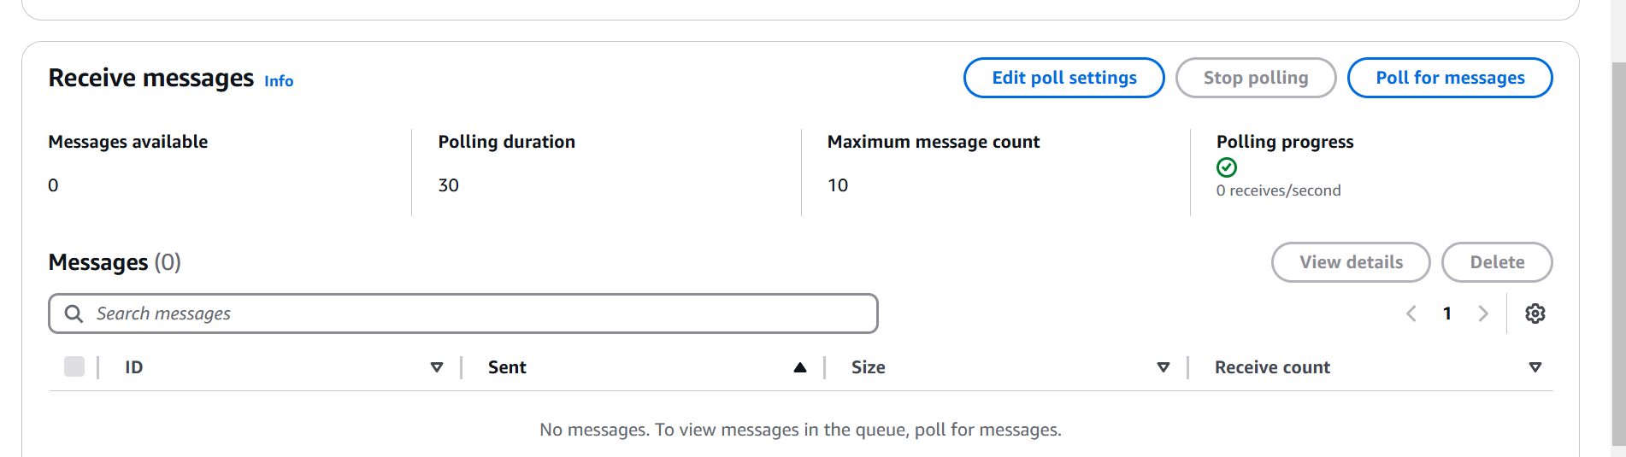

Go to lambda and check for cloud watch logs

* Go to ‘**CloudWatch**’ service on AWS console.
* From left-hand menu, please click ‘**Log groups**’ under the ‘**Logs**’ section.
* Click on ‘**/aws/lambda/sqs-poller**’
* Click on the “**Log streams**” and look at the message sent from SQS and processed by Lambda.

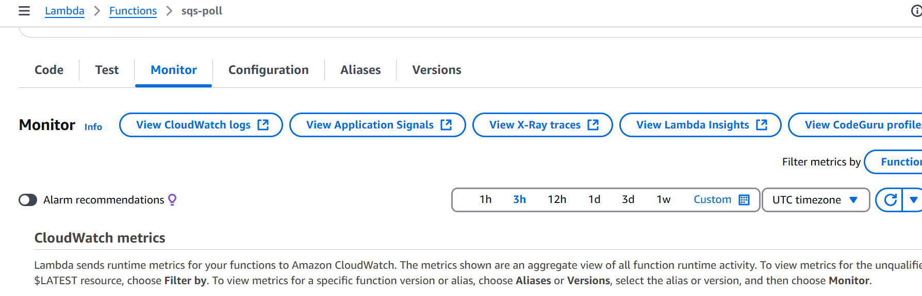

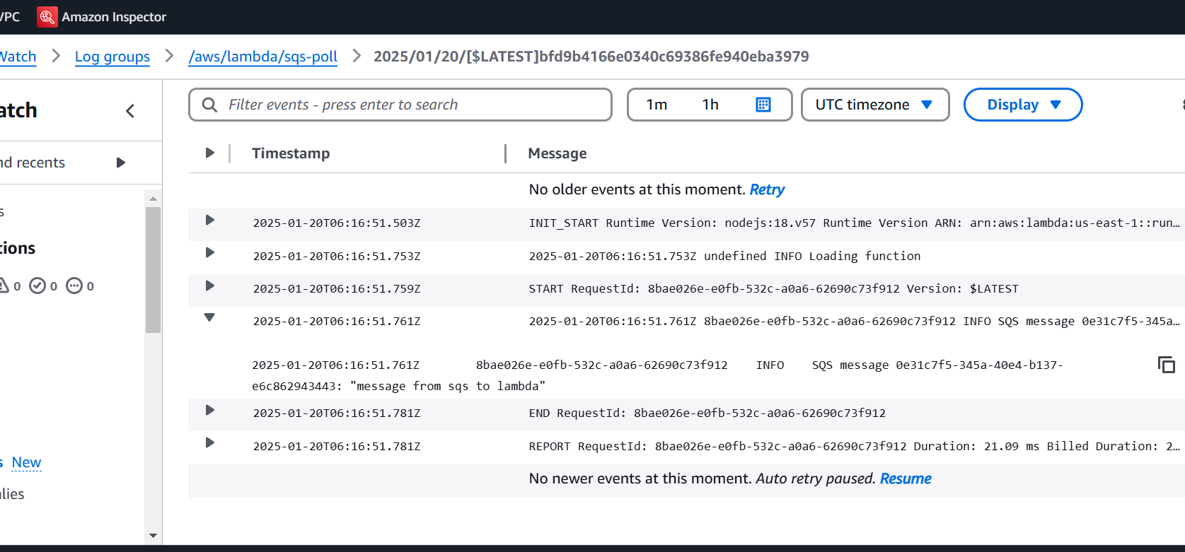

Delete lambda function and sqs